Task 1.
Unigram, Bigram and Trigram models were calculated. The most frequent grams are (gram, then frequency, then probability): 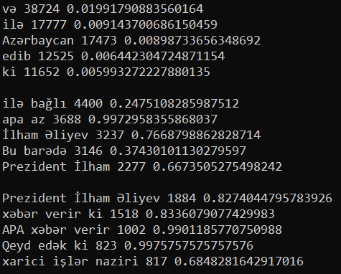
The calculated perplexity was:
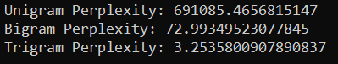
Task 2.
Smoothing algorithms were tried to be applied.
Task 3.
Naïve Bayes and Naïve Bayes Binary were applied to the translated datasets. Both algorithms have shown similar results for the datasets. The accuracy for positive/negative was quite low (~67%). The accuracy for objective/subjective was quite high (~89%).
Positive/negative Naïve Bayes:
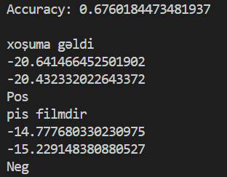
Positive/negative Naïve Bayes Binary:
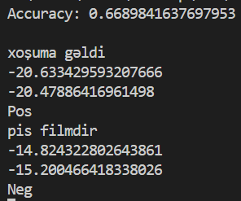
Objective/subjective Naïve Bayes:
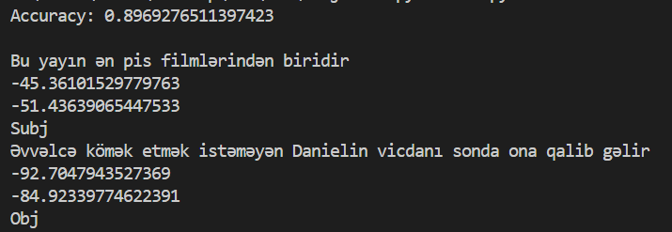
Objective/subjective Naïve Bayes Binary:
